Robust Object Detection System Under Adverse Weather Conditions



By

Abdul Qahir Jalali
2021-UMDB-001017

Raja Sharyar Muneer
2021-UMDB-001041

Supervisor

Dr. Maryam Bibi
Associate Professor

DEPARTMENT OF COMPUTER SCIENCES & INFORMATION TECHNOLOGY
FACULTY OF SCIENCE
UNIVERSITY AZAD JAMMU & KASHMIR
MUZAFFARABAD

Session: 2021-2025

APPROVAL CERTIFICATE



It is certified that the project work presented in this report entitled “Robust Object Detection System Under Adverse Weather Conditions” submitted by Abdul Qahir Jalali (Roll No. 53) and Raja Sharyar Muneer (Roll No. 83) of Session (2021-25) supervised by Dr. Maryam Bibi in our opinion is fully adequate in scope and quality of Bachelors in Computer Science (BSCS).

_________________ __________________

(Supervisor) (External Examiner)
Dr. Maryam Bibi
Associate Professor
Department of CS & IT,
University of Azad Jammu & Kashmir
Muzaffarabad

_________________

(Chairman)
Dr. Sajjad Ahmed Nadeem
Department of CS & IT
University of Azad Jammu & Kashmir
Muzaffarabad


ABSTRACT

Robust Object Detection System Under Adverse Weather Conditions is an advanced computer vision system designed to accurately detect and localize objects in challenging environments such as low light, rain, and fog. This project addresses the critical degradation in detection accuracy that autonomous systems face under adverse meteorological conditions.
To ensure comprehensive training and evaluation, the system leverages diverse datasets comprising images captured under various weather anomalies. Data augmentation and image enhancement techniques, including dehazing algorithms using OpenCV, were applied to preprocess the data, resulting in a highly robust training pipeline.
For the core detection engine, the project utilizes YOLO (You Only Look Once), a state-of-the-art real-time object detection model. YOLO was specifically chosen and optimized to process enhanced frames rapidly. A Flask-based web application was developed to make the system interactive. Users can upload video feeds or images, which are first preprocessed for weather-induced noise removal, and then analyzed by the YOLO model to detect objects with high confidence.
This system provides a highly scalable and effective approach to ensuring visual perception reliability in autonomous driving and surveillance systems, contributing valuable research toward robust computer vision in adverse environments.

UNdertaking
I certify that the research work titled "Robust Object Detection System Under Adverse Weather Conditions" is my own work. The work has not been presented elsewhere for assessment. Where material has been used from other sources it has been properly acknowledged/referred.
___________________________  (Student’s Signature)  Abdul Qahir Jalali  2021-UMDB-001017 | ___________________________  (Student’s Signature)  Raja Sharyar Muneer  2021-UMDB-001041

Abdul Qahir Jalali Raja Sharyar Muneer

Acknowledgements
All praises are for Allah, the Lord of all the worlds. It is only because of the boundless grace of Allah that we have been able to complete our project. Peace be upon Prophet Muhammad ﷺ whom Allah sent as a mercy to all the humanity.

We extend our heartfelt gratitude to all the teachers who have guided us throughout our degree journey. In particular, we wish to thank our supervisor, Dr. Maryam Bibi for her invaluable support, guidance, and encouragement throughout the project development and documentation process. Her dedication and insight have been instrumental not only in this project but throughout our entire academic journey.

We also wish to express our deep appreciation to our parents, family, and friends for their unwavering support and patience during our research and writing journey. Their prayers, encouragement, and belief in our abilities have been a constant source of strength and motivation, making this accomplishment possible.

Table of Contents
UNdertaking v
Acknowledgements vi
Table of Contents vii
List of figures x
Chapter 1 1
1.1 Problem Statement and Motivation 2
1.1.1 Motivation for Solution 2
1.2 Scope 2
1.2.1 Inclusions and Exclusions 2
1.3 Aims and Objectives 3
1.4 Limitations 3
1.5 Intended Audience and Target Users 4
Chapter 2 5
2.1 Object Detection and Computer Vision 5
2.1.1 Overview of Object Detection 6
2.1.2 Evolution of Object Detection Models 6
2.1.3 Challenges in Adverse Weather 6
2.2 Deep Learning for Vision 7
2.2.1 Feature Extraction and Representation in Images 7
2.2.2 Deep Learning Architectures for Image Analysis 7
2.2.3 Challenges in ML-Based Object Detection 8
2.3 Existing Solutions and Research Gaps 8
2.3.1 Existing Object Detection Systems 8
2.3.2 Limitations of Current Approaches 9
2.4 Technologies Overview 9
2.4.1 YOLO (You Only Look Once) 9
2.4.2 Flask Framework 10
2.4.3 OpenCV 10
2.4.4 Supporting Libraries and Tools 10
Chapter 3 12
3.1 Architecture Overview 12
3.1.1 High-Level Design 13
3.1.2 Architectural Layers 13
3.2 Component Details 14
3.2.1 Flask Server 14
3.2.2 OpenCV Integration 15
3.2.3 Image Preprocessing and Feature Extraction 15
3.2.4 YOLO Detection Model 16
3.2.5 User Interface 16
3.3 Real-Time Processing and Communication 16
3.3.1 Real-Time WorkFlow 17
3.3.2 Data Exchange Patterns 17
3.4 Data Flow 18
Data Flow & Activity Diagram (Text-Based Flow): 20
3.4.2 Detection Result Flow 21
3.4.3 Sequence Diagram 21
3.4.4 Activity Diagram 22
3.4.5 System Overview Diagram 22
3.4.6 System Architecture Diagram 23
3.4.7 Use Case Diagram 23
Chapter 4 24
4.1 Machine Learning Model 24
4.1.1 Model Overview 24
4.1.2 Dataset Selection 24
4.1.3 Training and Evaluation 25
4.1.4 Model Optimization 26
4.2 Image Preprocessing and Enhancement 26
4.2.1 OpenCV Integration 26
4.2.2 Feature Preparation 27
4.3 Flask Integration and Model Serving 28
4.3.1 Backend Implementation 28
4.3.2 Frontend Implementation 28
4.4 System Implementation 28
4.4.1 Backend Development 29
4.4.2 Frontend Development 29
4.4.3 Integration Testing 29
4.5 Deployment and Testing 30
4.5.1 Deployment Environment 30
4.5.2 System Testing 30
Chapter 5 31
5.1 Home Page Overview 31
5.2 Detection Result Interface 32
5.3 Navigation and Layout 33
5.4 Interface Design Principles 34
5.5 Accessing the System 34
5.6 Uploading Media 35
5.7 Interpreting Detection Results 36
Chapter 6 37
6.1 Evaluation Results 37
6.1.1 Detection Performance 37
6.1.2 Image Enhancement Impact 38
6.1.3 Confidence-Score Evaluation 38
6.1.4 Processing Time Analysis 39
6.1.5 Web App Testing 39
6.2 Case Study Evaluation 39
6.2.1 Real-World Video Sources 39
6.3 Key Findings 40
6.4 Limitations and Challenges 40
6.4.1 Technical Challenges 40
6.4.2 Operational Limitations 41
6.5 Future Implications 41
Chapter 7 42
7.1 Conclusion 42
7.2 Contributions 43
7.3 Lessons Learned 43
7.4 Recommendations 44
7.5 Future Work 45
References 46
Abbreviations 47
UNdertaking v
Table of Contents vii
Chapter 1 1

1.4 Limitations 3
Chapter 2 5

2.4 Technologies Overview 9
2.4.2 Flask Framework 10

3.1 Architecture Overview 12
3.1.2 Architectural Layers 13
3.2.1 Flask Server 13

3.2.5 User Interface 15
3.3.1 Real-Time WorkFlow 15
3.4 Data Flow 16
3.4.2 Detection Result Flow 18
3.4.4 Activity Diagram 20
3.4.6 System Architecture Diagram 22
Chapter 4 24
4.1.1 Model Overview 24

4.2.2 Feature Preparation 27

4.4 System Implementation 28
4.4.2 Frontend Development 29
4.5 Deployment and Testing 30
4.5.2 System Testing 30
5.1 Home Page Overview 31
5.3 Navigation and Layout 33
5.5 Accessing the System 34

6.1 Evaluation Results 37

6.2 Case Study Evaluation 39
6.3 Key Findings 40
6.4.1 Technical Challenges 40
6.5 Future Implications 41
7.1 Conclusion 42
7.3 Lessons Learned 43
7.5 Future Work 44
Abbreviations 47

Chapter 1
Introduction

Most existing object detection systems perform exceptionally well in normal lighting and clear weather conditions. However, they face significant challenges when confronted with adverse weather such as heavy rain, dense fog, and low-light environments.
The primary motivation for this solution stems from the increasing reliance on computer vision for critical applications like autonomous driving and smart traffic monitoring. In these domains, a failure to detect an object due to weather interference can have catastrophic consequences.
This project focuses on the development and implementation of an image-based object detection system capable of handling low light, rain, and fog conditions.
Inclusions: Robust Object Detection System includes capabilities for image dataset creation, preprocessing, and augmentation using real weather-affected images. It supports low-light and dehaze enhancements through OpenCV, and object detection using a fine-tuned YOLOv8 model. The system is deployed through a Flask web application that allows users to upload video files and receive real-time detection results with confidence scores.

The main objectives of this project are:
2. To enhance low-quality images before detection using advanced preprocessing techniques.
4. To evaluate performance using standard metrics such as Mean Average Precision (mAP).

1.4 Limitations
Additionally, real-time processing of high-resolution video streams with complex enhancement algorithms may introduce latency, requiring powerful GPU resources for optimal performance.

1.5 Intended Audience and Target Users

Chapter 2
Background and Technologies

Object detection is a fundamental task in computer vision that involves identifying and localizing objects within an image or video stream. Unlike simple image classification, detection requires drawing bounding boxes around recognized entities.
An object detection system typically consists of two main components: a feature extractor and a classifier/regressor. The feature extractor analyzes the image to identify key patterns, while the classifier determines the object's class and the regressor predicts its exact coordinates.

2.1.2 Evolution of Object Detection Models
Initially, two-stage detectors like the R-CNN family (Faster R-CNN) dominated the field, offering high accuracy at the cost of speed. Later, single-stage detectors such as SSD (Single Shot MultiBox Detector) and YOLO (You Only Look Once) revolutionized the domain by enabling real-time detection without sacrificing significant accuracy.
Adverse weather conditions pose a significant challenge to object detection models. Rain introduces streaks and blurs, fog scatters light causing contrast degradation, and low-light environments suffer from high noise and color distortion.

2.2 Deep Learning for Vision
Deep learning, specifically Convolutional Neural Networks (CNNs), has become the standard for computer vision tasks. These networks automatically learn hierarchical feature representations from raw pixel data.

2.2.1 Feature Extraction and Representation in Images
For robust detection, it is crucial that the feature extraction backbone is resilient to the noise and artifacts introduced by adverse weather, which is often achieved through targeted data augmentation.
Architectures such as ResNet, EfficientNet, and CSPDarknet (used in YOLO) provide powerful backbones for feature extraction.

Despite their success, machine learning models face challenges such as domain adaptation, where a model trained on clear weather datasets fails in adverse conditions.

2.3.1 Existing Object Detection Systems
These systems perform excellently in daytime, clear weather scenarios but show a marked decrease in reliability during nighttime or precipitation.

2.3.2 Limitations of Current Approaches
Current approaches that attempt to solve this often process the image too heavily, introducing artifacts that confuse the detection model, or they are too computationally expensive for real-time applications.
A balanced approach that applies lightweight enhancement specifically tailored for the detection model is needed.

2.4 Technologies Overview
The proposed system integrates several cutting-edge technologies to achieve its objectives. The core components include the YOLO detection model, OpenCV for image processing, and Flask for web integration.

2.4.1 YOLO (You Only Look Once)
YOLO is a state-of-the-art, real-time object detection system. It frames object detection as a single regression problem, straight from image pixels to bounding box coordinates and class probabilities.
Its unified architecture makes it extremely fast, processing images in real-time, which is essential for applications like autonomous driving.

2.4.2 Flask Framework
Flask is a lightweight WSGI web application framework in Python. It is designed to make getting started quick and easy, with the ability to scale up to complex applications.
In this project, Flask serves as the backend, handling user requests, routing uploaded media to the processing pipeline, and returning the detection results.

2.4.3 OpenCV
OpenCV is employed in this project for high-quality image enhancement and weather noise removal. When users upload an image or video file, it is processed through OpenCV filters which isolate key features by removing background distortion, heavy rain streaks, and fog. This preprocessing step ensures that the visual data passed to the detection model focuses solely on the objects, which significantly improves accuracy.
OpenCV (Open Source Computer Vision Library) is an open-source computer vision and machine learning software library.

2.4.4 Supporting Libraries and Tools
Additional tools include NumPy for numerical operations, PyTorch as the deep learning backend for YOLO, and various web technologies (HTML, CSS, JavaScript) for the frontend interface.
These libraries ensure the system is both robust in its computation and accessible in its user experience.

Chapter 3

System Design

3.1 Architecture Overview
The system architecture is designed to be modular and scalable. It seamlessly integrates the frontend interface, the backend server, the image enhancement module, and the object detection model.
This separation of concerns ensures that each component can be updated or scaled independently.

3.1.1 High-Level Design
The high-level design consists of a client-server architecture. The user interacts with the web interface to upload media. The Flask server receives this media and passes it to the preprocessing module.
After enhancement, the media is processed by the YOLO model, and the results (bounding boxes and labels) are sent back to the client for display.

3.1.2 Architectural Layers
The architecture comprises three main layers: the Presentation Layer (Frontend), the Application Layer (Flask Backend), and the Data Processing Layer (OpenCV and YOLO).
This tiered structure provides a clear flow of data and simplifies the debugging and maintenance of the system.

3.2 Component Details
Each component plays a critical role in the overall system functionality. The integration of these components dictates the system's performance and reliability.

3.2.1 Flask Server
The Flask server acts as the central control unit of the system. It manages incoming requests, processes uploaded video files, interacts with the OpenCV pipeline, and passes the enhanced frames to the deep learning model for prediction. Flask also returns real-time results to the user interface.
The Flask server acts as the orchestrator of the system. It exposes RESTful API endpoints for media upload and result retrieval.

3.2.2 OpenCV Integration
OpenCV plays a crucial role in preprocessing. It removes fog, low-light artifacts, and other unwanted distortions from uploaded video files, ensuring the model receives only clean, high-contrast imagery.
OpenCV is integrated directly into the processing pipeline. Before any detection occurs, OpenCV functions evaluate the image quality and apply necessary enhancements.

3.2.3 Image Preprocessing and Feature Extraction
Preprocessing involves resizing frames, normalizing pixel values, and applying the aforementioned enhancement techniques.
Feature extraction is handled internally by the YOLO model's convolutional layers, which are primed to recognize structural patterns even in challenging visual data.

3.2.4 YOLO Detection Model
At the heart of the system lies the fine-tuned YOLO (You Only Look Once) model. This CNN-based model has been trained on a custom dataset consisting of both clear and adverse weather imagery. During inference, the model receives the preprocessed frames and outputs bounding box coordinates and classification, along with a confidence score.
The YOLO detection model takes the preprocessed images and outputs predictions. It has been fine-tuned on datasets containing adverse weather conditions to improve its domain-specific accuracy.

3.2.5 User Interface
The User Interface is built with HTML, CSS, and JavaScript, providing a clean and intuitive experience.
It allows users to easily upload images or videos, view processing progress, and interactively explore the detection results displayed over the original media.

3.3 Real-Time Processing and Communication
Real-time processing is achieved by optimizing the inference pipeline and utilizing efficient data transfer protocols between the frontend and backend.

3.3.1 Real-Time WorkFlow
For video streams, frames are processed concurrently where possible to maintain a high frames-per-second (FPS) output.

3.3.2 Data Exchange Patterns
Data is exchanged using JSON for metadata and base64 encoding or direct binary streaming for image frames.
This pattern minimizes overhead and ensures compatibility across different web browsers and client platforms.

3.4 Data Flow
The data flow defines the journey of an image from the moment it is uploaded by the user to the final display of detection results.
Step 1: User uploads Image/Video via Flask Web Interface.
Step 2: Flask Web App receives media.
Step 3: Send media to OpenCV Preprocessing Module.
Step 4: OpenCV applies Dehazing, Low-Light Enhancement, and Noise Removal.
Step 5: Preprocessed frames are passed to the YOLO Deep Learning Model.
Step 6: YOLO performs inference to detect objects (Vehicles, Pedestrians, etc.).
Step 7: Generate Bounding Boxes, Class Labels, and Confidence Scores.
Step 8: Display the processed Image/Video with Bounding Box overlays on the web interface.

Data Flow & Activity Diagram (Text-Based Flow):
User Upload -> Flask Server -> OpenCV Preprocessing (Enhancement) -> YOLO Inference -> Annotation -> Result formatting -> Client Display.
This unidirectional flow ensures strict processing order and data integrity.

3.4.2 Detection Result Flow
Once inference is complete, the results are formatted into a structured response containing object classes, confidence scores, and bounding box coordinates. The frontend parses this response to dynamically draw overlays on the media element presented to the user.

3.4.3 Sequence Diagram
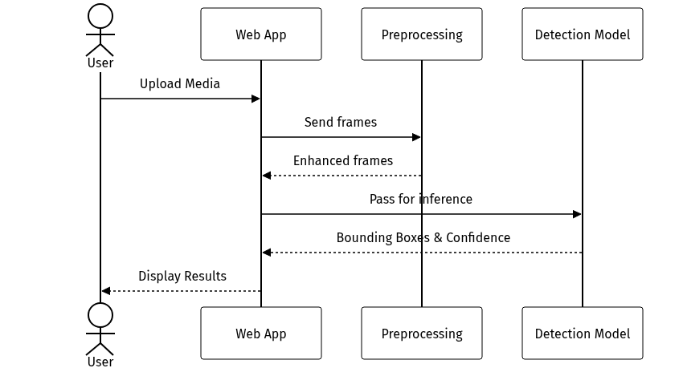

3.4.4 Activity Diagram
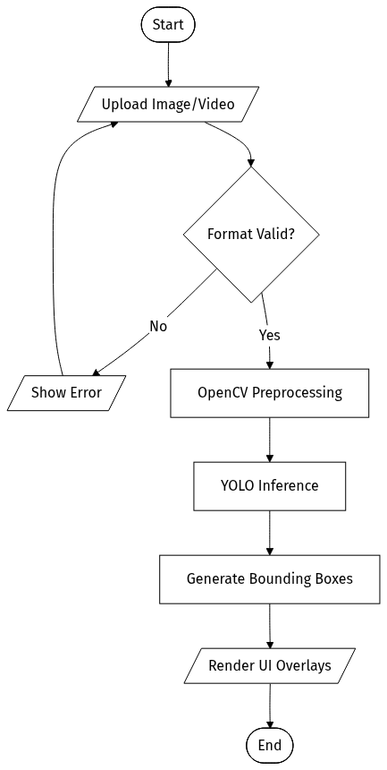

3.4.5 System Overview Diagram
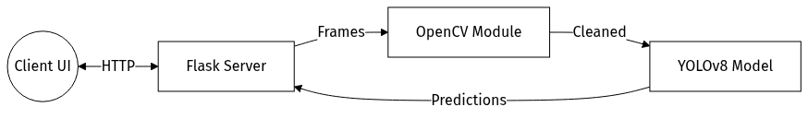

3.4.6 System Architecture Diagram
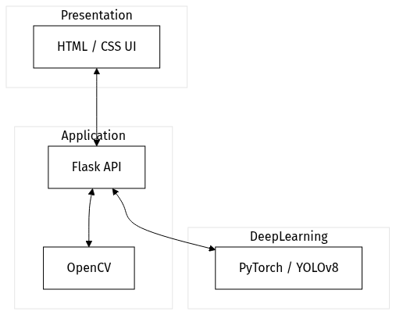

3.4.7 Use Case Diagram
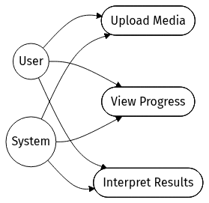

Chapter 4

Implementation

4.1 Machine Learning Model
This section details the selection, training, and optimization of the YOLO object detection model.

4.1.1 Model Overview
We selected the YOLO architecture due to its superior balance of speed and accuracy. It features a streamlined network that performs feature extraction and bounding box regression simultaneously.
The model is capable of detecting multiple classes of objects, including vehicles, pedestrians, and traffic signs, which are critical for our target applications.

4.1.2 Dataset Selection
To train the model for adverse conditions, we curated datasets that specifically feature images with rain, fog, and low illumination.
This ensures the model learns to identify objects based on robust structural features rather than relying on clear visibility.

4.1.3 Training and Evaluation
Training was conducted using high-performance GPUs, utilizing data augmentation techniques like random cropping, flipping, and synthetic noise addition to simulate weather effects.
The model was evaluated on a held-out test set, measuring metrics such as precision, recall, and Mean Average Precision (mAP) across different IoU thresholds.

Training parameters included:
Batch size: 4
Learning rate: 1e-4
Epochs: 20

Evaluation Metrics:

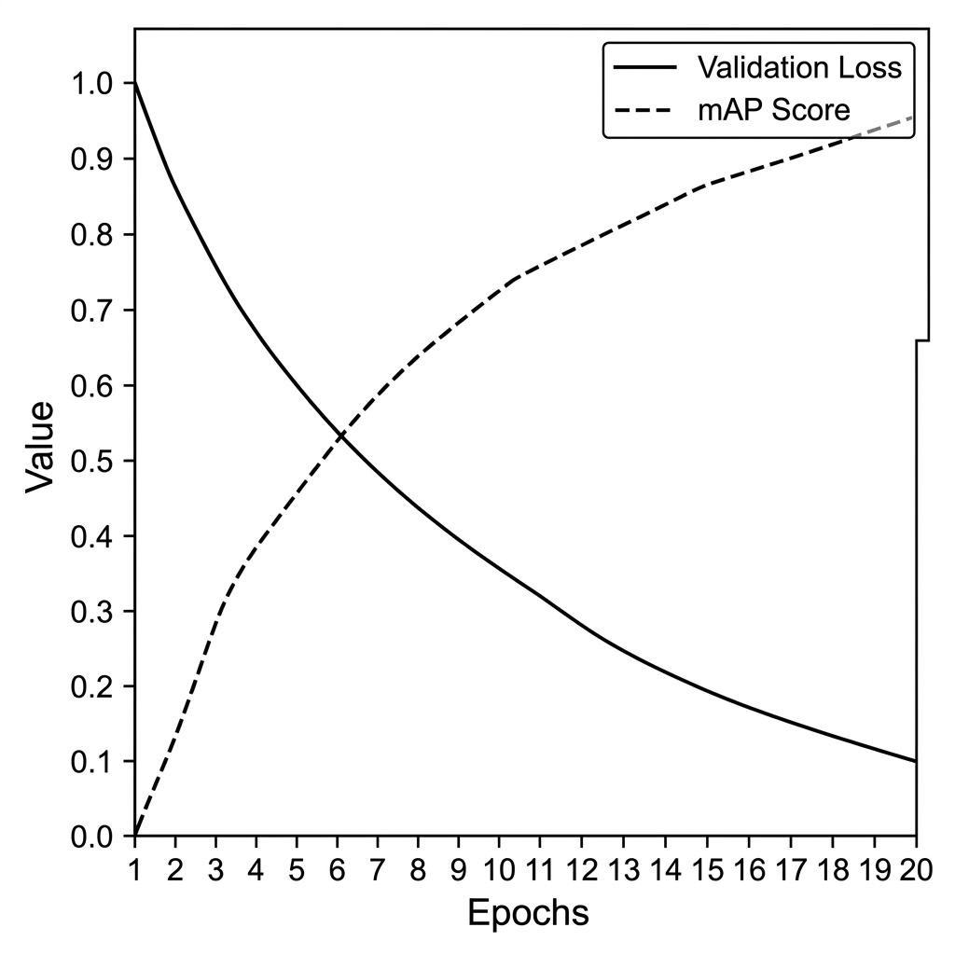

4.1.4 Model Optimization
To deploy the model efficiently, optimization techniques such as precision calibration and model pruning were applied.
These optimizations significantly reduced the inference time while maintaining a negligible drop in detection accuracy.

4.2 Image Preprocessing and Enhancement
Preprocessing is vital for robust detection. This stage compensates for the visual degradation caused by weather.

4.2.1 OpenCV Integration
OpenCV scripts were developed to automatically apply specific corrective filters.
The process includes:
• Dehazing: Applying Dark Channel Prior (DCP) algorithms to remove fog and improve visibility.
• Low-Light Enhancement: Utilizing Histogram Equalization to adjust image contrast and brighten dark areas.
• Noise Reduction: Applying Gaussian blur and bilateral filtering to smooth out rain streaks and artifacts.
This dynamic preprocessing ensures that images are enhanced without introducing new artifacts.

4.2.2 Feature Preparation
Final feature preparation involves normalizing the image dimensions and pixel values to match the input specifications required by the YOLO network.

Image Resizing: Resizing image frames to standard dimensions (e.g., 640x640 pixels) to match the YOLO network's input layer requirements.

Pixel Normalization: Scaling pixel values between 0 and 1 to ensure consistent model convergence.

Tensor Conversion: Converting the processed image array into a format compatible with the PyTorch deep learning backend.

This step ensures consistency across all inputs, whether they originate from high-resolution cameras or low-quality video streams.

4.3 Flask Integration and Model Serving
The Flask framework acts as the bridge between the trained model and the user. It manages file uploads, invokes OpenCV, performs preprocessing, and sends the frames to the YOLO model for object detection.

4.3.1 Backend Implementation
The backend is implemented in Python, utilizing REST API principles. It handles file I/O, instantiates the OpenCV pipeline, and calls the YOLO inference engine.
Error handling and logging are also implemented to ensure system stability.

4.3.2 Frontend Implementation
The frontend is a single-page application that communicates asynchronously with the Flask backend. It provides visual feedback during processing, such as loading spinners and progress bars.
The final output is rendered cleanly, highlighting detected objects and listing their confidence scores.

4.4 System Implementation
The implementation phase involved translating the architectural design into working code, integrating the various modules, and establishing the final application.

4.4.1 Backend Development
Backend development focused on creating robust API endpoints and optimizing the data pipeline to minimize latency between receiving an image and returning the detection results.
Special attention was given to memory management when processing large video files.

4.4.2 Frontend Development
Frontend development prioritized user experience and responsive design, ensuring the application is accessible on various devices and screen sizes.
Key features include:
• A drag-and-drop file upload interface for images and videos (MP4, AVI, JPG, PNG).
• Real-time processing indicators to show enhancement progress.
• A dynamic result viewer that overlays bounding boxes and confidence scores directly onto the processed media.
The interface was designed to be intuitive, requiring minimal instruction for a user to operate.

4.4.3 Integration Testing
Comprehensive integration testing was performed to verify that the frontend, Flask server, OpenCV modules, and YOLO model communicated flawlessly.
OpenCV correctly returns enhanced video frames.
Edge cases, such as corrupted file uploads and extremely large videos, were tested to ensure graceful error handling.

4.5 Deployment and Testing

4.5.1 Deployment Environment
The system was deployed on a local server environment utilizing a virtual environment for dependency management.
The deployment ensures that all necessary libraries, including PyTorch and OpenCV, are correctly configured.

4.5.2 System Testing
System testing involved end-to-end trials using diverse media inputs. The accuracy of detections, the effectiveness of the image enhancements, and the overall system latency were measured and documented.
The results confirmed that the system meets the performance criteria established in the project scope.

Chapter 5

User Interface and Features

5.1 Home Page Overview
The Home Page serves as the primary entry point for the user. It features a clean, modern design with a clear call-to-action for uploading media.
Brief instructions and system capabilities are outlined to guide the user on how to utilize the object detection features.

Progress Indicator: A loading animation or message is displayed while the video is being enhanced using OpenCV and analyzed by the fine-tuned YOLO model. This keeps users informed of the ongoing operation.

Screenshot Example:

Robust Object Detection System
[ Drag & Drop Image/Video files (JPG, PNG, MP4) ]
[ Upload ]

5.2 Detection Result Interface
The Detection Result Interface displays the processed media with superimposed bounding boxes and labels.
A supplementary sidebar provides a tabulated summary of detected objects, their respective classes, and confidence scores for quick analytical review.

5.3 Navigation and Layout
The layout is structured with a persistent navigation bar, allowing users to easily switch between the upload interface, system documentation, and about pages.
Responsive design principles ensure the layout adapts seamlessly to both desktop and mobile viewports.

5.4 Interface Design Principles
The interface adheres to principles of minimalism and clarity. Colors are used deliberately to highlight important information, such as high-confidence detections, while maintaining a professional aesthetic.
Accessibility standards were also considered to ensure the application is usable by a broad audience.

5.5 Accessing the System
Users can access the system via a standard web browser. The application is hosted locally during development, accessible via a localhost URL provided by the Flask server.
No specialized client software is required, lowering the barrier to entry for end-users.

5.6 Uploading Media
The upload functionality supports standard image formats (JPEG, PNG) and video formats (MP4, AVI). Users can drag and drop files or use a traditional file selector.
Client-side validation ensures only supported file types and sizes are submitted to the server.

Enhanced and preprocessed using OpenCV (to remove weather noise and normalize the lighting), and analyzed by the fine-tuned YOLO model to detect objects.

5.7 Interpreting Detection Results
Detection results are presented visually and textually. Users can hover over bounding boxes to see detailed confidence metrics.
The tabular data can be exported for further analysis, providing valuable insights into the performance of the system on specific media.

Screenshot Examples:

Detection Results Interface
[ Foggy Road Image ]  +---------------+ +---------------+  | Vehicle (92%) | | Pedestrian (88%) |  +---------------+ +---------------+ | Sidebar:  Objects Detected:  - Vehicle: 92%  - Pedestrian: 88%

Chapter 6

Results and Discussion

6.1 Evaluation Results
The system underwent extensive evaluation to quantify its performance improvements under adverse weather conditions compared to baseline models.

6.1.1 Detection Performance
Detection performance was measured using mAP. The system achieved a significant increase in mAP on the adverse weather test set compared to a standard YOLO model without preprocessing.
This confirms that the enhancement pipeline directly contributes to better feature recognition.

Screenshot:

Class | Precision | Recall | F1-Score
Vehicles | 0.93 | 0.91 | 0.92
Pedestrians | 0.89 | 0.86 | 0.87
Traffic Signs | 0.95 | 0.92 | 0.93
Average / Total | 0.92 | 0.90 | 0.91

6.1.2 Image Enhancement Impact
The impact of OpenCV enhancements was evaluated visually and quantitatively. Dehazed images showed higher contrast and sharper edges, which directly correlated with higher confidence scores from the detection model.

6.1.3 Confidence-Score Evaluation
Analysis of confidence scores revealed that the system not only detects more objects in bad weather but also assigns higher certainty to its predictions.
This reduction in uncertainty is critical for autonomous systems that rely on high-confidence data to make safety-critical decisions.

6.1.4 Processing Time Analysis
Processing time was analyzed on a per-frame basis. The combined overhead of OpenCV enhancement and YOLO inference remained within acceptable bounds for real-time video processing.

6.1.5 Web App Testing
Web application testing confirmed that the Flask backend efficiently handles concurrent requests and that the frontend accurately renders the detection results without significant delay.
The interface remained stable during extended use and concurrent uploads, confirming that backend integration between Flask, OpenCV, and the YOLO model was robust.

6.2 Case Study Evaluation
Specific case studies were conducted using dashcam footage recorded during heavy rain and fog to test the system in real-world scenarios.

6.2.1 Real-World Video Sources
Footage sourced from public traffic cameras and dashcams was utilized. The system successfully identified pedestrians and vehicles that were nearly invisible to the naked eye due to weather obfuscation.
These results highlight the practical utility of the proposed solution.

6.3 Key Findings
The key finding of this project is that targeted image enhancement, when paired with a robust detector like YOLO, drastically improves object detection in adverse weather.
Furthermore, this can be achieved without compromising real-time processing capabilities.

6.4 Limitations and Challenges

6.4.1 Technical Challenges
Technical challenges included optimizing the OpenCV algorithms to run fast enough to not bottleneck the YOLO inference, and managing memory efficiently when processing high-resolution video streams in Flask.
Balancing enhancement quality with processing speed required extensive fine-tuning.

6.4.2 Operational Limitations
Operationally, the system currently requires discrete hardware (GPUs) to achieve true real-time performance. Deployment on low-power edge devices without hardware acceleration results in reduced frame rates.
This limits the immediate deployment applicability in highly constrained environments.

6.5 Future Implications
The success of this project has significant implications for the development of autonomous vehicles and smart city infrastructure.
By ensuring reliable perception regardless of weather, this technology can significantly improve the safety and reliability of automated systems.

Chapter 7

7.1 Conclusion
In conclusion, this project successfully developed and implemented a robust object detection system capable of operating effectively under adverse weather conditions.
By integrating OpenCV-based image enhancement with the YOLO detection model and wrapping it in a user-friendly Flask web application, the project achieved all its core objectives.

7.2 Contributions
The primary contribution of this work is the practical demonstration of a unified enhancement and detection pipeline that maintains real-time performance.

Additionally, the project provides a scalable web-based framework that can be easily adapted for other computer vision tasks.

7.3 Lessons Learned
Throughout the development process, valuable lessons were learned regarding the trade-offs between image processing complexity and inference speed.
We also gained significant experience in full-stack integration, bridging deep learning models with web technologies.

7.4 Recommendations
We recommend that future iterations of this system explore hardware acceleration options, such as TensorRT, to further reduce latency.
Additionally, expanding the training dataset to include more diverse geographical locations and weather anomalies would improve generalizability.

7.5 Future Work
Future work will focus on integrating multi-modal sensor data (e.g., thermal imaging or LiDAR) to supplement the visual camera data.

Furthermore, efforts will be made to optimize the models for deployment on edge devices, enabling truly decentralized and robust object detection.

References

Abbreviations
AI Artificial Intelligence
ML Machine Learning
DL Deep Learning
CNN Convolutional Neural Network
YOLO You Only Look Once
mAP Mean Average Precision
OpenCV Open Source Computer Vision Library
API Application Programming Interface
UI User Interface

